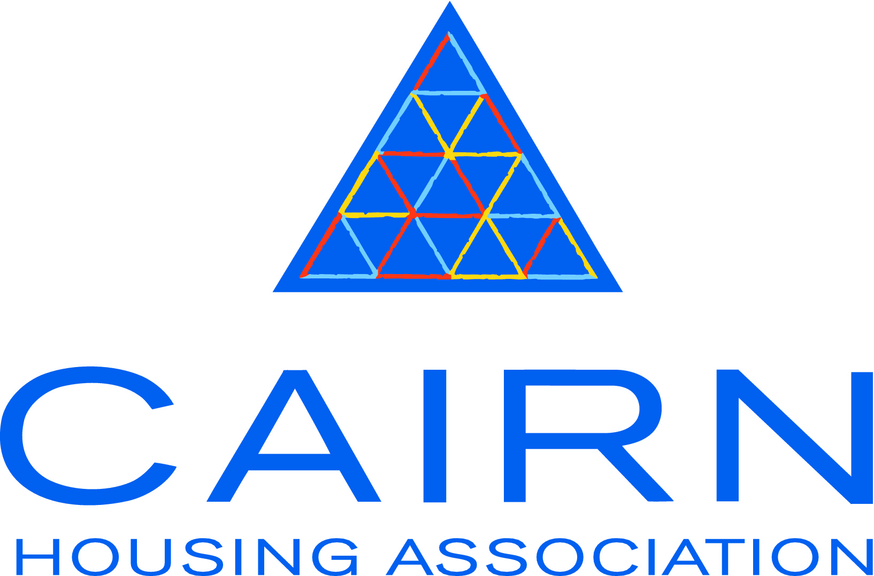

Post: Part time Housing Officer, Inverness

Information for applicants about Cairn Housing Association

Our mission is to provide good quality affordable homes and services, with our communities and partners throughout Scotland.

We are here for our tenants and customers to help meet the housing and wider needs of local communities.

Our head office is in Edinburgh and we also have offices in Bellshill, Inverness and Thurso. We have 210 full and part time staff.

We are regulated by the Scottish Housing Regulator and we work in partnership with the Scottish Government and local authorities across Scotland.

The Board of Management is our governing body, whose role is to provide strategic direction for the organisation, with advice and professional support from the Chief Executive and Senior Management Team. The Board is made up of individuals, including tenants, with a wide range of professional skills and experience.

Cairn was formed as an independent organisation in 1990. We are a not-for-profit organisation with charitable status and governed by the legislation and regulatory standards required of Registered Social Landlords.

Cairn manages almost 3,500 homes across 24 local authority areas. We have a range of partnerships with councils and voluntary agencies, providing a range of housing and support services.

Our properties include:

General Needs Housing is suitable for anyone aged 16 or over. Available in a range of sizes and types, it is suitable for single people, couples and families.

Amenity Housing has specific design features, such as raised sockets that make these properties particularly appropriate for anyone with a medical need or older people who wish to live independently.

Retirement Housing is specifically designed with older people in mind. Tenants live independently in flats or bungalows, with a range of additional shared facilities.

About the Customer Services Team
The Director of Customer Services is responsible for the delivery of housing management, repairs, housing support and care services. Services are delivered to our tenants, residents and other customers throughout 24 local authority areas. In delivering these high quality services the Customer Services department works closely with other Teams at Cairn.

About the North Area Team
Based in Inverness and Caithness, all staff within the North Area team are managed by the Head of Customer Services (Tenancy Services) and Head of Customer Services (Property Investment). Cairn’s Property Investment team is responsible for planned improvements to existing housing stock.
Cairn’s Customer Services team in the North is responsible for the management and maintenance of approximately 1,500 Association tenancies dispersed throughout the Highlands and Aberdeenshire.
The Care and Repair Team is responsible for providing an administrative service to assist older and disabled people living in the private sector to improve their housing conditions.
In the North Area there are 7 Retirement Housing Developments, 1 Supported Housing scheme with around 25 associated staff working in these developments.

About the job
Please see the enclosed role profile.

About our Terms and Conditions of Employment

Salary
The salary for this post is £11,833 - £14,791 per annum, dependent on qualifications and experience. Maximum entry point is £12,424 per annum.

Hours of work
13.5 hours per week. Working hours are Thursday, 9.00 am - 5.00 pm, Friday 9.00 am – 4.30 pm, with an unpaid meal break of an hour. Although not contractual, flexi-time is in operation.

Annual leave
10.5 days annual leave per annum, increased to 11 days after three full years service after 1st October. After a further two years service at 1st October the entitlement is increased to 12 days.

Public holidays
10 public holidays. Two days are taken at Easter with the remaining eight days taken over Christmas and New Year. Public holidays are pro rata for part time staff.

Company Sick Pay
Please note there is no company sick pay in the first 6 month’s continuous service

Probationary Period
Your employment would be subject to a probationary period of six months.

Training and development
We are fully committed to ongoing development for all employees.

About our application process

General
Please do not enclose your C.V. We need information from all applicants to be presented in a consistent format as shortlisting decisions will be based on the information you provide in the application form. It is therefore important that you complete all sections of the form as fully as possible. If you require more space than the form allows, please continue on a separate sheet. Your application form will be photocopied so please complete it in black ink or typeface.

Role Profile
This details the main purpose and duties of the role and sets out what we consider are the essential and desirable requirements for this post. The information you supply on the application form should address these requirements as this will demonstrate your skills, abilities, experience and competencies relevant to the post.

Relatives of Cairn staff or Board members
We ask if you are related to employees or Board members as housing associations are legally required to identify and record this information to prevent any suspicion of favouritism. Being related to staff or Board members does not prevent you from being employed with us, but failure to disclose such a relationship may do so. Details should include the nature of relationship, for example, niece or husband, and the name of the employee or Board member. If in doubt, please ask.

References
Please supply names and contact details of two people who can comment on your suitability for the post. One of these must be your current employer (or, if you are unemployed, your last employer). Referees should not be close relatives, friends or partners. References will not be contacted until after interview.

Qualifications
Under the heading of University/College/Other, please also include qualifications gained through other forms of learning such as correspondence, open or distance.

Please do not enclose copies of qualification certificates with your application. If you are invited to interview you will be asked to bring evidence of your highest relevant qualifications with you.

Other relevant training
Use this space to tell us about any other relevant training you have undertaken, which has not led to a recognised qualification but which is relevant to the post you are applying for.

Present or most recent employment
If you have been with your current or last employer for a number of years and have held different posts during that time, please clarify this. If any of the earlier posts held were more relevant to the post you are applying for, please ensure that you tell us about them.

Statement in support of application
Please provide us with any additional information which helps to show how you meet the requirements of the post. Include experience gained through voluntary work, if relevant.

Disclosure Scotland
The successful candidate will be subject to a criminal conviction check through Disclosure Scotland, the cost of which will be met by Cairn.

Asylum and Immigration Act 1996
In order to comply with the Asylum and Immigration Act 1996 Cairn has to be satisfied that you are legally able to work in the U.K. If you are invited to interview you will be asked to bring appropriate documentation with you, for example, a passport, birth certificate, P60.

Equal opportunities
We strive to be an equal opportunities employer and we welcome applications from people irrespective of their sex, religion or belief, nationality, ethnic origin disability or sexual orientation.

Our commitment to applicants with disabilities
As a ‘Positive About Disabled People’ symbol user, we are committed to a positive approach to persons who consider themselves to have a disability under the legislation and undertakes to fulfil various disability commitments outlined by Jobcentre Plus to those persons.

The Disability Discrimination Act (DDA) 1995 defines a disability as:

- A physical or mental impairment which has a substantial and long term adverse effect on a person's ability to carry out normal day-to-day activities

One of our commitments relates to guaranteeing an interview to all disabled applicants who meet the minimum criteria for the job.

In relation to the DDA 1995, we ask all job applicants to complete the section on the application form regarding whether you consider yourself to have a disability and, if you do, whether you wish to take advantage of a guaranteed interview if you meet all the essential criteria as outlined in the person specification. However, there is no requirement to complete this form.

Returning your completed application form
Completed application forms must be returned to us at the address below or to recruitment@cairnha.com by the closing date of 17 November 2015.

If you are submitting your application in the post, please ensure that you pay the correct postage cost, otherwise your application may miss the deadline.

Interviews are intended to be held in Inverness on 23 November 2015.

If you have any queries about your application, or the recruitment process in general, please contact the HR Team on 0800 990 3405 (free from landlines) or 0300 456 1245 (local rate from mobiles).
Cairn Housing Association
Citypoint
65 Haymarket Terrace
Edinburgh
EH12 5HD

recruitment@cairnha.com

www.cairnha.com

