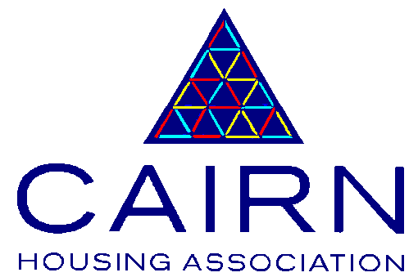CAIRN HOUSING ASSOCIATION: EQUALITY AND DIVERSITY STATEMENT OF VALUES

We are committed to promoting equality of opportunity and diversity in our role as a provider of housing and related services, as an employer, and in all other areas of our business.

We understand the need to recognise and value individual difference. This allows everyone to contribute to their full potential, and acknowledges the importance of this, to the success of the organisation.

We believe that everyone is entitled to be treated with dignity, respect and fairness, regardless of their, age, gender, race, religious belief, sexual orientation, disability, marital or parental status, socio-economic background/social class, caring responsibilities, Trade Union activities or unrelated criminal offences. This list is not exhaustive.

In addition to meeting our statutory responsibility we will promote equality of opportunity in all our activities by reflecting best practice.

This statement of values applies to all employees, Committee of Management members, and volunteers, and we expect our agents and contractors to adopt a similar approach.

We are committed to supporting our values by:

- Putting our Customer First – we always aim to achieve high quality outcomes for customers.

- We value Excellence and quality and aim to achieve high standards in all we do. We always strive to be the best that we can be.

- We are Accountable for our actions and we take responsibility and ownership for outcomes.

- We work as One Team and build excellent working relationships to achieve our goals.

- We value high standard of fairness, treating everyone with consideration and Dignity. We should this through our everyday works and actions – Respect.

March 2015

A registered Scottish Charity No.SC016647

