- 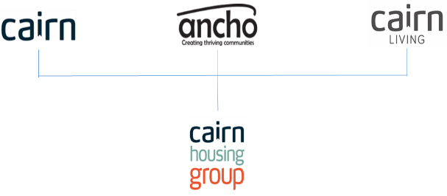
Job Description

1. JOB DETAILS

Job Title: Handyperson

Location: Kirkcaldy Aitkin Court

Team/Directorate: Tenancy Services

Responsible To: Housing Officer/Court Coordinator

Responsible For: n/a

2. JOB PURPOSE

To ensure standards of safety are maintained, undertake tasks as identified by the line manager and maintain confidentiality at all times

3. KEY RESULT AREAS/PRINCIPLE DUTIES AND RESPONSIBILITIES

- Deliver an effective day to day service within the Court to provide excellent customer service to tenants
- Maintain the common areas and carry out small repairs to ensure that the court is kept to a high standard
- Monitor the standard of repairs carried out to ensure a qualitative and value for money service is provided
- Responsible for reporting repairs to Homeworks team, Court Coordinator or Housing Officer to ensure repairs are carried out.
- Assist/Schedule weekly fire alarm system checks to comply with Fire and Safety Regulations.

3.2 Key Performance Indicators

Monitored through the estate management process as well as the customer satisfaction surveys.

Achieve agreed Service Standard:
Estate Management
Customer Care
Cornerstone
Complaints

3.3 Key Contacts – Internal & External

- Cairn Staff/Cairn Agents
- Tenants/customers
- External contractors and agencies

3.4 Health & Safety
- Ensure that Health and Safety guidelines and fire regulations are strictly adhered to
- Comply with safe working practices as defined by Cairn Housing Group
- Complete online training as and when required
- Take reasonable care for your own health and safety and that of others who may be affected by acts or omissions at work
- Report any accidents, incidents or near misses as soon as reasonably practicable.
- Manage own wellbeing and pressures relating to lone working, travel, difficult environments and challenging situations.

3.5 General
- Be aware of and adhere to Cairn Housing Group policies at all times
- Take part in progress/performance reviews throughout the year
- Cooperate with other Cairn Housing Group departments
- Attend training courses and complete online training modules as required to meet the requirements of the post
- Take responsibility for own personal development, seeking out opportunities to learn new skills
- Undertake any other duties as requested by management which are reasonably deemed to be within the scope of the role
- Support organisation in deploying resources to allow the business to function effectively

3.6 Other

- Apply the Cairn Housing Group values and behaviours to every aspect of the role at all times
- Promote and maintain the brand standards of Cairn Housing Group

JOB TITLE

Person Specification

CRITERIA | ESSENTIAL | DESIRABLE
Qualifications and specific training | n/a
Experience | DIY/General maintenance skills | Experience within a similar role.
Knowledge |  | - Knowledge of Health and Safety requirements
Skills | - IT & computer literate  - Good communication and interpersonal skills | Manage daily workload
Personal attributes | Ability to work to own supervision.  Awareness of confidentiality.  Able to adapt communication to suit audience.  Pleasant and curious manner while being able to be empathetic | Have a common sense approach.  Resilience
Additional requirements

Job Description and Person Specification Agreement:
The above job description is not exhaustive but an indication of the duties the post holder may undertake and will be subject to review.

Post Holders Signature: Date:

Managers Signature: Date:

