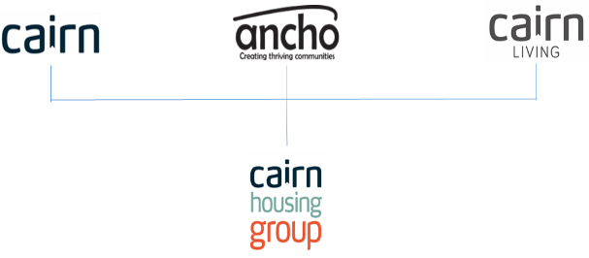
Job Description

1. JOB DETAILS

Job Title: : IT Hardware and Infrastructure Assistant

Location: Edinburgh/Bellshill/Inverness

Team/Directorate: Business Services

Responsible To: ICT and Digital Transformation Manager

Responsible For: N/A

2. JOB PURPOSE

Second Tier IT Support Assistant you will need to provide excellent customer service, who is a team player, who is organised, and pays attention to detail. You will support the digital delivery and provide that key support to Cairns employees.

3. KEY RESULT AREAS/PRINCIPLE DUTIES AND RESPONSIBILITIES

- Demonstrate the principles of continuous improvement in all tasks and promote these principles through partnership working with colleagues across the Group to embed continuous improvement
- Co-ordinate the production and timely delivery of performance information for both Boards and the management teams within the Group to assist in identifying areas for performance improvement and inform the strategic decision-making process.
- Extract and manipulate data from a variety of sources for the production of regulatory reporting to help the Group to fulfil its regulatory obligations
- Promote the effective use of all available business systems and devices to ensure staff have the right tools to support service delivery.
- Responsible for IT hardware asset management
- Troubleshooting customer IT issues remotely and on-site
- Server checks and proactive maintenance
- System configuration and repair
- User access and security administration

3.2 Key Performance Indicators

Achieve high levels of internal satisfaction

3.3 Key Contacts – Internal & External

Staff Members - Cairn Group (All Staff), Cairn Board, ANCHO Board
External Partners – TSG, SHN, SFHA, SHR, Netcall
External Suppliers - O2, Ricoh

3.4 Health & Safety
- Ensure that Health and Safety guidelines and fire regulations are strictly adhered to
- Comply with safe working practices as defined by Cairn Housing Group
- Complete online training as and when required
- Take reasonable care for your own health and safety and that of others who may be affected by acts or omissions at work
- Report any accidents, incidents or near misses as soon as reasonably practicable.

3.5 General
- Be aware of and adhere to Cairn Housing Group policies at all times
- Take part in progress/performance reviews throughout the year
- Cooperate with other Cairn Housing Group departments
- Attend training courses and complete online training modules as required to meet the requirements of the post
- Take responsibility for own personal development, seeking out opportunities to learn new skills
- Undertake any other duties as requested by management which are reasonably deemed to be within the scope of the role

3.6 Other

- Apply the Cairn Housing Group values and behaviours to every aspect of the role at all times
- Promote and maintain the brand standards of Cairn Housing Group

Business Improvement Assistant

Person Specification

CRITERIA | ESSENTIAL | DESIRABLE
Qualifications and specific training | - HND level/other relevant qualification or 3 years relevant experience in a similar business support / reporting role
Experience | - Experience within a project team role  - Experience of providing 2nd tier technical support  - Experience of building and maintaining IT devices (Widows 10/11, Android OS, ect…)
Knowledge | - Knowledge of Microsoft Stack such as MS SQL, MS Exchange, etc.  - Knowledge of M365 products and licensing, specifically SharePoint  - Windows Server 2012/2016  - Active Directory, Group Policy  - Good networking skills and understanding of TCP/IP, router configuration, DHCP, DNS etc.  - Good understanding of cloud technologies  - Knowledge of Antivirus and Security products | - Knowledge of the Social Housing Sector in Scotland  - Knowledge or RDS platforms  - Knowledge of InTune  - Linux and Open Source Database
Skills | - Excellent numeracy skills  - Excellent verbal and written communication skills  - Attention to detail and accuracy  - Logical approach to problem solving  - Ability to prioritise workload, work independently and to strict deadlines  - Excellent IT skills in Windows, Office 365, Active Directory, Antivirus, and networking.  - Ability to communicate effectively with both technical and non-technical individuals  - Experience with reporting
Personal attributes | - Confident, enthusiastic, flexible and adaptable  - A positive and creative problem-solving analytical thinker  - Strong interpersonal skills to build and maintain working relationships and work as part of a team  - Customer and outcome focussed  - Ability to assesses the importance of objectives, activities and events in relation to organisational goals  - Able to maintain high performance levels under pressure and/or opposition  - Resilient in the face of disappointments, criticism or failures  - Ability to plan and organise own use of time effectively to meet deadlines and priorities  - Use initiative to gather information relevant to organisational issues, trends  - Proactively applies new, job-related skills and approaches to improve service delivery
Additional requirements | - This role is based in the Edinburgh office but supports the Group and it’s locations  - Willingness to travel to other office locations and remote sites and able to occasionally stay away from home overnight  - This role is eligible for flexible and home working arrangements as authorised by the BIM. | - Valid driver’s licence and car available for business use

Job Description and Person Specification Agreement:
The above job description is not exhaustive but an indication of the duties the post holder may undertake and will be subject to review.

Post Holders Signature: Date:

Managers Signature: Date:

