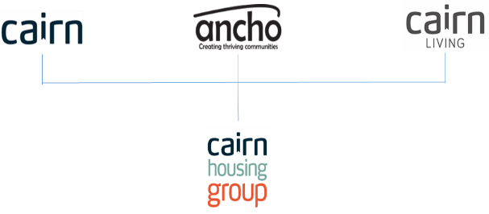
Job Description

1. JOB DETAILS

Job Title: Customer Service Advisor

2. JOB PURPOSE

To provide an excellent and consistent service to all internal and external customers, using different communication channels and promoting future digital and ongoing changes within the organisation.
Providing a first point of contact for all enquiries and to have a vast knowledge of all departments within the organisation ensuring correct and efficient responses are delivered against our agreed service standards and key performance indicators.

3. KEY RESULT AREAS/PRINCIPLE DUTIES AND RESPONSIBILITIES

- Maintains the day to day operation of the Cairn Connect service, taking ownership of customer enquiries and ensuring customer information is efficiently and effectively handled within agreed service level agreements to meet the expectations of our customers.

- Delivers a high level of customer service to all internal and external customers using various sources including, telephone, email, face to face, webchat and other digital platforms to ensure an excellent customer journey.

- Perform effective data capture/management using various software systems, to enable accurate reporting and monitoring.

- Maintain and assist with partnership working across the group to ensure collaborative working and consistency of service in key areas and to promote a streamlined one team way of working.

- Assisting in the delivery of key business services, including Income Management payments and administration, Tenancy Services housing enquires, antisocial behaviour, Repairs reporting and invoice administration and general day to day business enquiries, where possible offering a first time resolution service to meet our key performance indicators.

- Specialise in the customer relationship management functionality and to provide a support desk service for advice and technical support to all staff.

- Provide first line advice on relevant policies and procedures to ensure a consistent service to all.

- Delivery of Cairn Connect services and campaigns to meet our agreed key performance indicators, service level agreements and legislative requirements

- Responsible for participating fully in all training required, including responding positively to coaching and support provided.

- Monitor effectiveness of systems used and identify areas for development or improvements to align with business needs and provide a streamlined customer journey.

- Provide support to a wide range of business areas in the delivery of service specific tasks and administrative duties to help develop the roles and responsibilities of the Cairn Connect team.

- Undertake clerical and general administrative duties this may include, imputing of customer satisfaction surveys, outbound calling, digital profiling, internal and external mail, system data cleansing, creating purchase orders, invoice approving, financial transactions and payments, updating and maintaining service specific systems, to support the team and wider organisation.

3.2 Key Performance Indicators

Cairn Connect Campaigns

Call Quality and Performance

Call Handling Levels

3.3 Key Contacts – Internal & External

Cairn Housing Group

New, Existing and Former Tenants

Government Departments

Local Authorities

Contractors

Internal & External Customers

Support Agencies and Local Health Care Professionals

3.4 Health & Safety
- Ensure that Health and Safety guidelines and fire regulations are strictly adhered to
- Comply with safe working practices as defined by Cairn Housing Group
- Complete online training as and when required
- Take reasonable care for your own health and safety and that of others who may be affected by acts or omissions at work
- Report any accidents, incidents or near misses as soon as reasonably practicable.

3.5 General
- Be aware of and adhere to Cairn Housing Group policies at all times
- Take part in progress/performance reviews throughout the year
- Cooperate with other Cairn Housing Group departments
- Attend training courses and complete online training modules as required to meet the requirements of the post
- Take responsibility for own personal development, seeking out opportunities to learn new skills
- Undertake any other duties as requested by management which are reasonably deemed to be within the scope of the role

3.6 Other

- Apply the Cairn Housing Group values and behaviours to every aspect of the role at all times
- Promote and maintain the brand standards of Cairn Housing Group

JOB TITLE

Person Specification

CRITERIA | ESSENTIAL | DESIRABLE
Qualifications and specific training |  | SVQ level 2 in a relevant subject or an equivalent qualification.
Experience | Experience of working in a frontline customer Contact Centre or similar role  Experience of delivering excellent a frontline customer service. | Working as part of a team.
Knowledge | An understanding of effective and best practice in a customer service. | Knowledge and experience of customer relationship management systems.  Knowledge of the Housing Sector.  Knowledge on complaints handling and SPSO guidelines.
Skills | Demonstrate high level of computer skills  Demonstrate excellent customer care skills  Good communicator and listener.  Highly developed skill of attention to details and ensuring accuracy.  Ability to update and maintain data accurately and efficiently and in a timely manner.  Demonstrate high level of communication and interpersonal skills.  Ability to embrace new and emerging technologies.
Personal attributes | Motivated  Approachable  Good Listening Skills  Empathetic  Focused  Team Player  Good Time Management
Additional requirements |  | Flexibility in working patterns to support the business needs and Cairn Connect team

Job Description and Person Specification Agreement:
The above job description is not exhaustive but an indication of the duties the post holder may undertake and will be subject to review.

Post Holders Signature: Date:

Managers Signature: Date:

