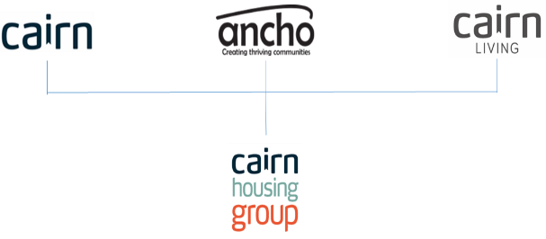
Job Description

1. JOB DETAILS

Job Title: Welfare Benefits Advisor

Location: Inverness/Thurso

Team/Directorate: Customer Services

Responsible To: Senior Housing Officer

Responsible For:

2. JOB PURPOSE

To provide our tenants with an up to date and comprehensive welfare benefits advice and income maximisation service. To provide an advocacy service for tenants undergoing appeals or attending tribunals. To roll out training or updates to staff to ensure they are kept informed of changes in the Welfare Benefit system.

3. KEY RESULT AREAS/PRINCIPLE DUTIES AND RESPONSIBILITIES

- Deliver services to meet our agreed KPI’s, SLA’s and legislative requirements.
- Assist and coordinate strategic projects which support organisational success and future proofing through the delivery of Strategic Action Plans.
- Engage with prospective tenants at an early stage to offer support or welfare benefit advice to enhance tenancy sustainment
- Deliver an excellent day to day advisory service to provide exceptional & consistent customer service.
- Perform effective data management to enable accurate reporting and monitoring.
- Build and maintain relationships through partnership working internally and externally to deliver a one team approach.
- Support colleagues and contribute towards training new staff and developing the team to ensure a consistent and high level of service to our customers.
- Resolve customer issues and queries and apply creative thinking to identify personalised solutions to the satisfaction of customers.
- Assist and respond to customer contacts, including complaints to ensure all queries are suitably resolved and within agreed SLA’s.
- Contribute to, influence and implement the development of policy and procedures to ensure that these are up to date and meet legislation and best practice requirements
- Seek out and access relevant material to ensure knowledge is kept up to date with changes to welfare benefits and other relevant sources of funding.

3.2 Key Performance Indicators

Meet agreed KPI rent loss due to voids.
Meet agreed KPI rent arrears & former tenant arrears.
Meet agreed KPI Tenancy Sustainment.

Achieve agreed Service Standard:
Estate management
Customer care.
Allocations
CXM targets & complaints

3.3 Key Contacts – Internal & External

Tenants

Local Authorities/Registered Social Landlords.
- Cairn Staff/Cairn agents.
- Social work/Support agencies/GP.
- External Contractors.
- Solicitors/Financial Trustees/Accountant in Bankruptcy.
- DWP/Money Advice/Citizens Advice.
- Police/Emergency services.
- HMRC/Third Sector.
- Tenant Appointees.

3.4 Health & Safety
- Ensure that Health and Safety guidelines and Fire Regulations are strictly adhered to.
- Comply with safe working practices as defined by Cairn Housing Group.
- Complete online training as and when required.
- Take reasonable care for your own health and safety and that of others who may be affected by acts or omissions at work.
- Report any accidents, incidents or near misses as soon as reasonably practicable.
- Manage own wellbeing and pressures relating to lone working, travel, difficult environments and challenging situations.

3.5 General
- Be aware of and adhere to Cairn Housing Group policies at all times.
- Take part in progress/performance reviews throughout the year.
- Cooperate with other Cairn Housing Group departments.
- Attend training courses and complete online training modules as required to meet the requirements of the post.
- Take responsibility for own personal development, seeking out opportunities to learn new skills.
- Undertake any other duties as requested by management which are reasonably deemed to be within the scope of the role.
- Support organisation in deploying resources to allow the business to function effectively.

3.6 Other

- Apply the Cairn Housing Group values and behaviours to every aspect of the role at all times.
- Promote and maintain the brand standards of Cairn Housing Group.

Welfare Benefits Advisor

Person Specification

CRITERIA | ESSENTIAL | DESIRABLE
Qualifications and specific training | Significant experience within a welfare benefits advisor role  (2-3 years) | Educated to HND level or other relevant professional qualification.  Experience of providing a debt advice service.
Experience | Extensive experience of working directly with customers to provide advice on welfare benefits  Experience of providing excellent customer service and supporting customers through potentially difficult situations. | Experience of providing an advocacy service for people undergoing appeals or attending tribunals
Knowledge | Basic understanding of housing legislation and best practice guidance.  Current understanding of Welfare Benefits and their interaction within the Social Housing sector. | .
Skills | Prioritisation and Time Management.  IT Literate. | Report & presentation writing.
Personal attributes | - Courteous  - Empathetic  - Respectful  - Good Listener  - Accountable  - Flexible  - Trustworthy  - Influence  - Negotiate  - Resilience  - Positive  - Delegation  - Team work & lone work
Additional requirements | - Valid driver’s license & access to a car for work.  - Provide cover at other sites as required.  - Attain a basic Disclosure Check.

Job Description and Person Specification Agreement:
The above job description is not exhaustive but an indication of the duties the post holder may undertake and will be subject to review.

Post Holders Signature: Date:

Managers Signature: Date:

