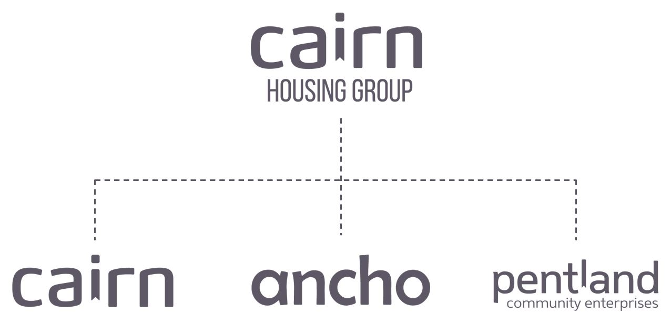

Cairn Housing Association
Corporate Officer Job Description

Post Title: Corporate Officer

Salary:

Responsible to: Governance Services Manager

Office Hours: 34.5 Hours

- Job Purpose:

To support the Governance Services Manager in the delivery of an excellent governance support and advisory service to the Group Boards, Committees and Executive Team.

To support the Health & Safety Manager for Cairn Housing Group to ensure safe and effective processes and procedures.

Key Result Areas/Principle Duties And Responsibilities

Support the Governance Services Manager with the operation of the governance function to provide an excellent administration service across the CHG Group.

Service and support meetings of the Boards, Committees, Working Groups and Staff Groups as directed by the Governance Services Manager, ensuring that meetings are organised, papers are co-ordinated, circulated, fully minuted and run according to the regulatory and organisational standards set and all required follow-up, records and registers kept, in compliance with organisational, regulatory and statutory requirements.

Lead on administration of the annual assurance statement process as directed, ensuring that management responses are co-ordinated promptly and effectively, and the Assurance Action Plan is updated and monitored regularly.

Ensure Shareholder registers for the Group are kept up to date in compliance with organisational, regulatory and statutory requirements. Develop and update systems and communication methods on a regular basis, issue Share Certificates.

In collaboration with the Governance Team co-ordinate the group’s Annual General Meetings including venue/equipment sourcing, collating correspondence, communications with shareholding members, Board, Executive Team and external stakeholders.

To manage and deliver on specific governance projects as specified by the Governance Services Manager throughout CHG.

Support the H&S Manager with the operation of the H&S function to provide an excellent service across the CHG Group.

To manage, administer, carry out and deliver on specific H&S projects as specified by the H&S Manager throughout CHG.

To carry out H&S administration as required, which may include but not limited to the collection and collation of performance metrics, to administer the H&S Group meetings and related employee consultations, to review and edit documents and any other H&S tasks.

Provide a high level of customer service when dealing with internal and external customers.

Ensure that all appropriate regulations are being observed throughout Cairn Housing Group.

Proactively develop and maintain relationships with internal and external stakeholders.

3.2 Key Performance Indicators

- Production and distribution of Group Board, Committee and Working Group papers and Minutes within statutory and agreed deadlines.
- Administration of the group annual assurance process and Action Plan

Management of statutory registers and databases
- Board members, Executive Team, Governance Services Manager and Health & Safety Manager Relations – first-time resolution of query
- H&S compliance, maintaining data and records.

3.3 Key Contacts – Internal & External

Group Board members

Executive Team, Extended Management Team and all staff
- External governance agencies
- External contractors and third parties relevant to H&S work.

3.4 Health & Safety
- Ensure that Health and Safety guidelines and fire regulations are adhered to.
- Promote a positive H&S culture.
- Comply with safe working practices as defined by Cairn Housing Group.
- Complete online training as and when required.
- Take reasonable care for your own health and safety and that of others who may be affected by acts or omissions at work.
- Report any accidents, incidents or near misses as soon as reasonably practicable.

3.5 General
- Promote a positive governance culture across the group.
- Be aware of and adhere to Cairn Housing Group policies and procedures at all times
- Take part in progress/performance reviews as required.
- Cooperate with other Cairn Housing Group departments.
- Attend training courses and complete online training modules as required to meet the requirements of the post.
- Take responsibility for personal development, seeking opportunities to learn new skills.
- Undertake any other duties as requested by management which are reasonably deemed to be within the scope of the role.
3.6 Other

- Adopt Cairn Housing Group values and behaviours to every aspect of the role at all times
- Promote and maintain the brand standards of Cairn Housing Group
- The post holder is required to perform any other duties as may reasonably be required by the needs of the business, including but not limited to the provision of holiday and absence cover for colleagues.

Person Specification

CRITERIA | ESSENTIAL | DESIRABLE
Qualifications and specific training | - Academic qualification and / or relevant industry qualification (continuous improvement) or  - Significant experience (3 yrs) in a similar role | - Governance/Business Admin qualification  - A relevant Health and Safety qualification
Experience | - Experience of working and supporting senior management teams.  - Experience of governance issues, servicing and supporting Boards of Management and Sub-Committees aligned to policy and procedural processes.  - In-depth experience of carrying out administrative duties including producing high quality Minutes and handling complex data. | - Experience in a social housing or third sector/charitable service organisation.  - Experience of working in H&S.
Knowledge | - Development and implementation of governance policies and procedures  - Administration and maintenance of management information systems and applications  - Knowledge of data extraction, presentation and analysis  - Continuous improvement methodologies | Knowledge of Social Housing Governance and Charity law  Knowledge of H&S processes, policies and procedures
Skills | - High quality, accurate minute taking for governing bodies, management teams and committees.  - Excellent IT Skills, particularly in MS Office applications.  - Ability to assess, prioritise and organise heavy workloads effectively, to work under pressure, make decisions and meet strict deadlines.  - Dealing with a range of sensitive and confidential matters relating to staffing, budgets and corporate decision making.  - A positive and creative problem solving attitude, working collaboratively with colleagues.  - Customer centred approach, flexible, confident and assertive manner.  - Presentation skills  - Strong interpersonal skills to build and maintain working relationships and work as part of a team.  - Excellent verbal and written communication skills.  - Resilience and ability to work under pressure to tight deadlines and coordinate a varied and complex workload.
Personal attributes | - Confident, enthusiastic, flexible and adaptable  - A positive and creative problem-solving attitude  - Strong interpersonal skills and ability to maintain good working relationships and work as part of a team  - Customer and outcome focussed  - Able to assesses the importance of objectives, activities, and events in relation to organisational goals  - Able to maintain high performance levels under pressure and/or opposition  - Resilient in the face of disappointments, criticism or failures  - Demonstrates team work and can take on the role of leader, peer, or subordinate  - Able to plan and organise own use of time effectively to meet deadlines and priorities  - Can use initiative to gather information relevant to organisational issues, trends and problems, and can establish processes to monitor progress and activities to ensure that goals are achieved  - Is proactive is the application of new skills and approaches to improve service delivery  - Able to scrutinise and challenge working practices and approaches
Additional requirements | - This role supports the Group and its locations  - Willingness to travel and to able to occasionally stay away from home overnight  - This role is eligible for flexible and home working arrangements as authorised by the manager | - Valid driver’s licence and car available for business use

